CSC Broward: Leveraging Integrated Data for Outcomes-Based Government
Background: The Children’s Services Council of Broward County (CSC Broward) is an independent special district, whose sole purpose is to better the lives of children and families. Its vision is to ensure that all children can achieve their full potential. With an annual budget of $70M, CSC Broward funds 150 programs for youth and families in the areas of family strengthening, delinquency prevention & diversion, early care & education, and out-of-school time. CSC Broward has a history of being data-driven and is committed to transparency, accountability, and outcomes-orientation in directing taxpayer dollars to the programs and providers that have the greatest positive impact on children and families.
Empowering Families Project: In support of these efforts, CSC Broward recently received the competitive, national “Empowering Families” grant from the Social Innovation Fund. The grant funds training from Actionable Intelligence for Social Policy (AISP) and Third Sector Capital Partners (Third Sector). AISP is supporting CSC Broward’s development of an Integrated Data System (IDS) that links interagency administrative data to measure program needs, services delivered, and outcomes achieved. Third Sector is enhancing CSC Broward’s outcomes-based approach to using data during procurement and in ongoing contract management to inform funding and service delivery.
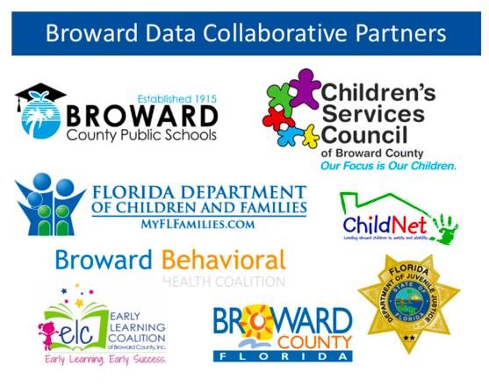
With the grant support, CSC Broward is partnering with other government agencies and providers to link data across agencies in the Broward Data Collaborative IDS. CSC Broward is also developing systems to evaluate that data with a racial equity lens that considers the historical context and elevates the lived experience of nonprofit provider staff and service recipients. CSC Broward then deploys the data for outcomes-based government practices in procurement and contract management. Together, the IDS and outcomes-based approaches improve the way the agency monitors services and uses quantitative and qualitative data to inform policy, advocacy, service delivery, and systems change.
Project Partners: AISP is a University of Pennsylvania initiative funded by the John D. and Catherine T. MacArthur Foundation that aims to improve the quality of social policies and practices through the use of integrated data systems (IDS). Third Sector is a 501(c)3 nonprofit consulting firm that advises governments, community organizations, and funders on how to define impact, draw insights from data, and implement outcomes-based contracts in order to address pressing community challenges. The Florida Children and Youth Cabinet (CYC) adopted the Broward Data Collaborative as a pilot to inform IDS development in Florida. The CYC Technology Workgroup has supported the Broward Data Collaborative with expertise on legal data- sharing agreements and enhanced security protocols.

